Message 2: Introducing the Lifestyle Assessment and kick-off meeting

Email subject: Watch the Lifestyle Assessment introduction video
Great to have you on board!
You should have received an email titled ”Welcome to Firstbeat Lifestyle Assessment”. Follow the link in the email to order your device straight to your home address.
Watch this short video to see how easy it is to conduct the measurement even at the busiest of times!
See the effects of your choices

Get ready for the measurement by playing our Lifestyle Assessment game!

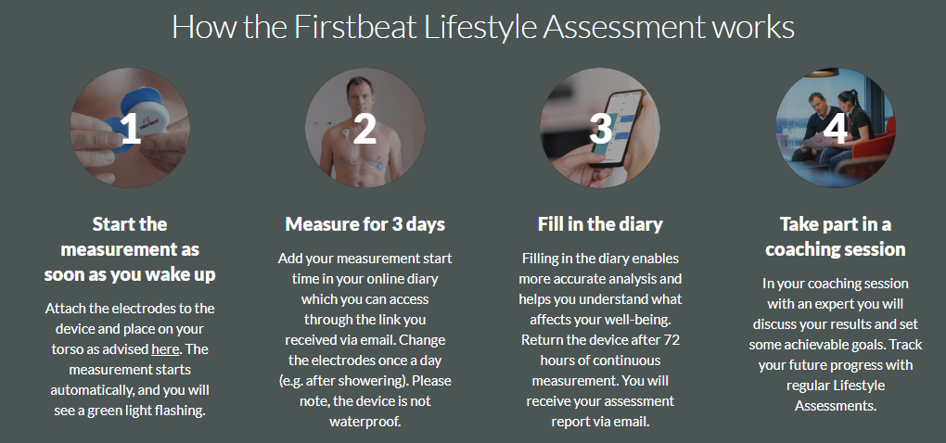

- Lifestyle Assessment timeline:
- The kick-off meeting timetable:

