Message 3: Have you started your assessment yet?

Email subject: Have you started your Firstbeat Lifestyle Assessment yet?

Improved wellness is just around the corner!

Give your daily life the boost it deserves with the Firstbeat Lifestyle Assessment. You have received an email titled “Welcome to Firstbeat Lifestyle Assessment” from service@firstbeat.com. Simply follow the link in the email you can order your device direct to your home address.
Your privacy is protected

Please note, the Lifestyle Assessment results are for your eyes only – your employer will not see your personal results at any stage. Read more about data processing from our Privacy policy.

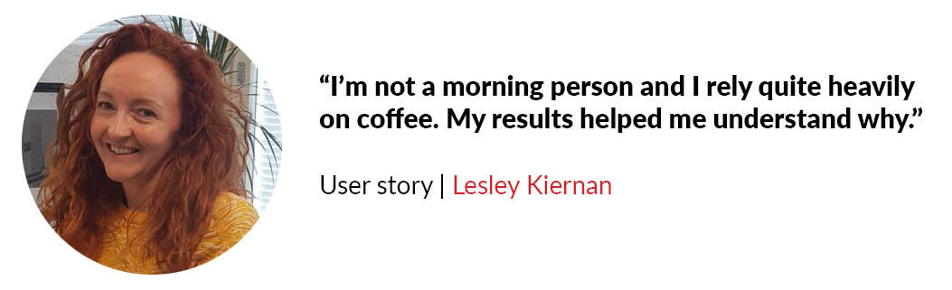

See how the Lifestyle Assessment has benefited other users:
https://www.firstbeat.com/en/your-best-self/

